RESULTS :

DATA VISUALISATION :

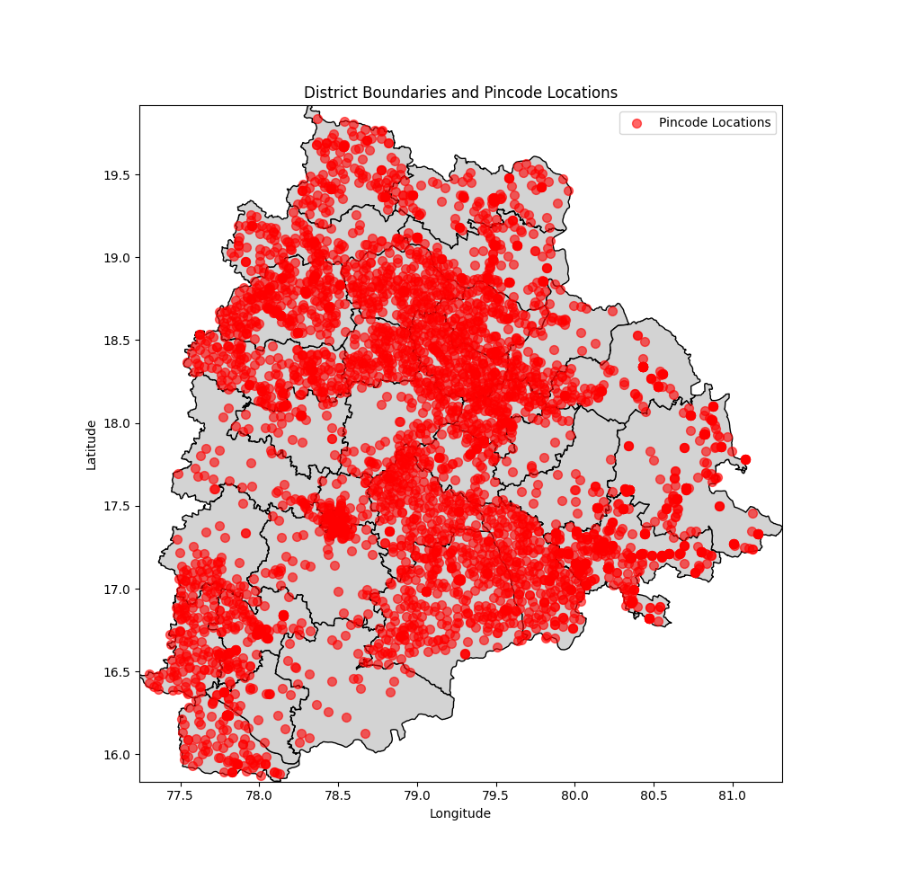

CLUSTERING ANALYSIS:

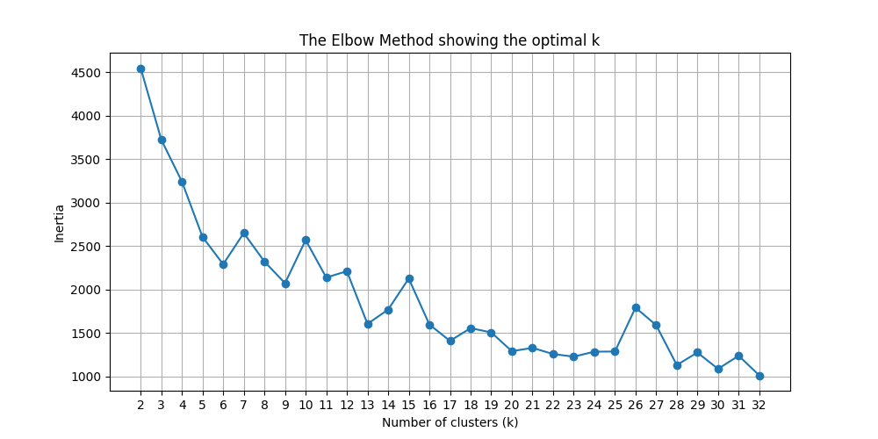

K = 20 looked best

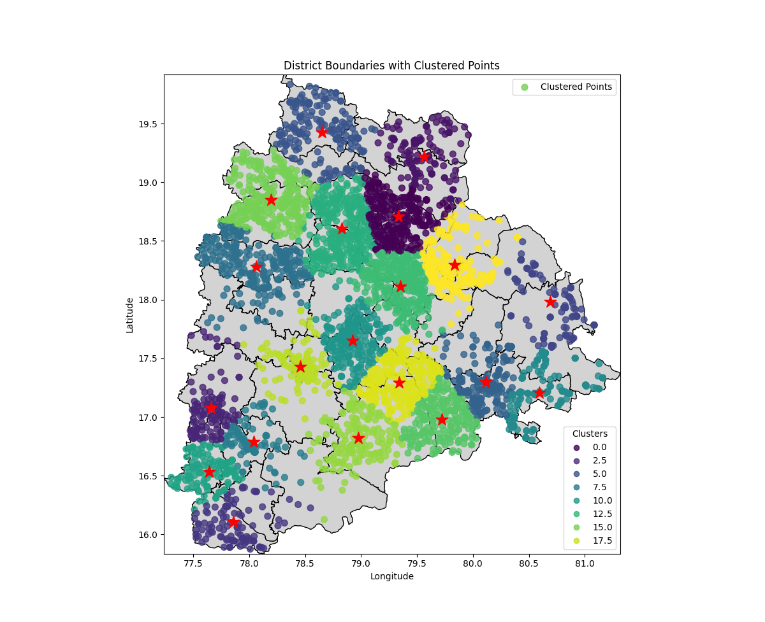

K = 3

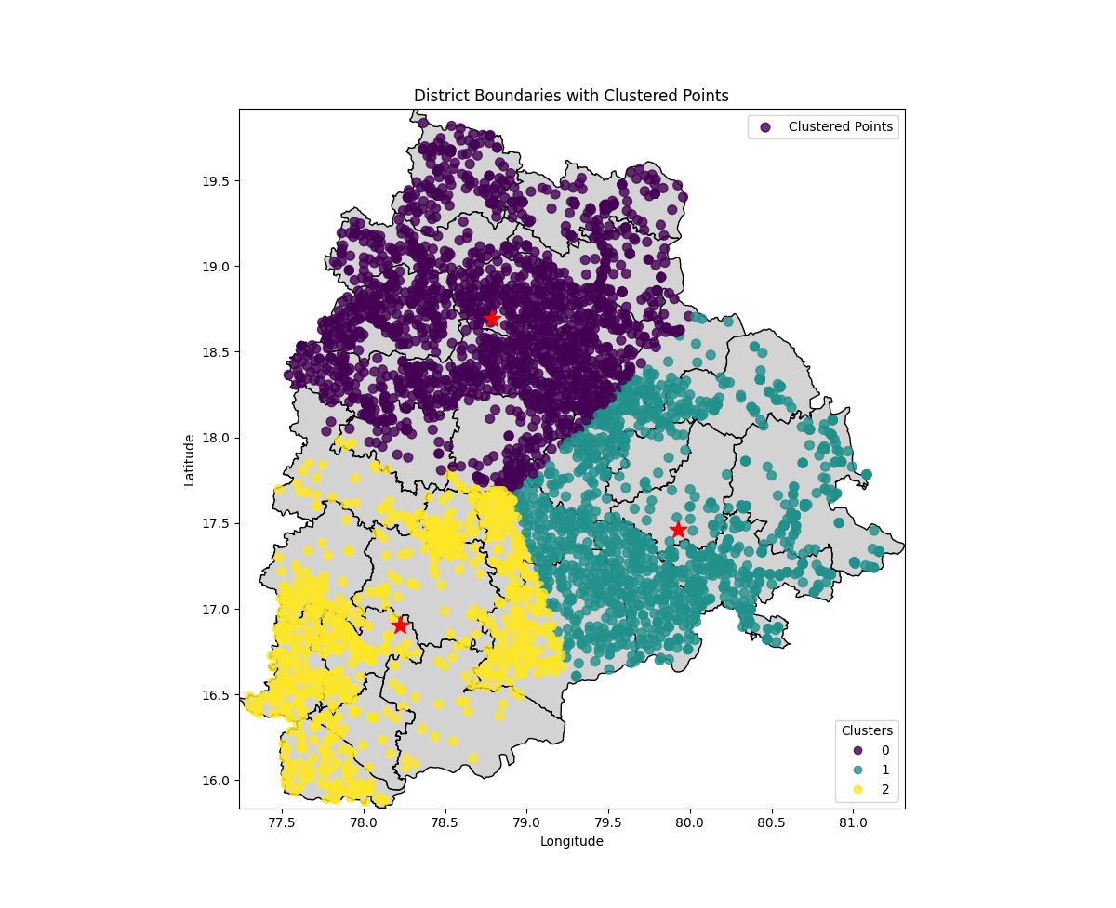K=4

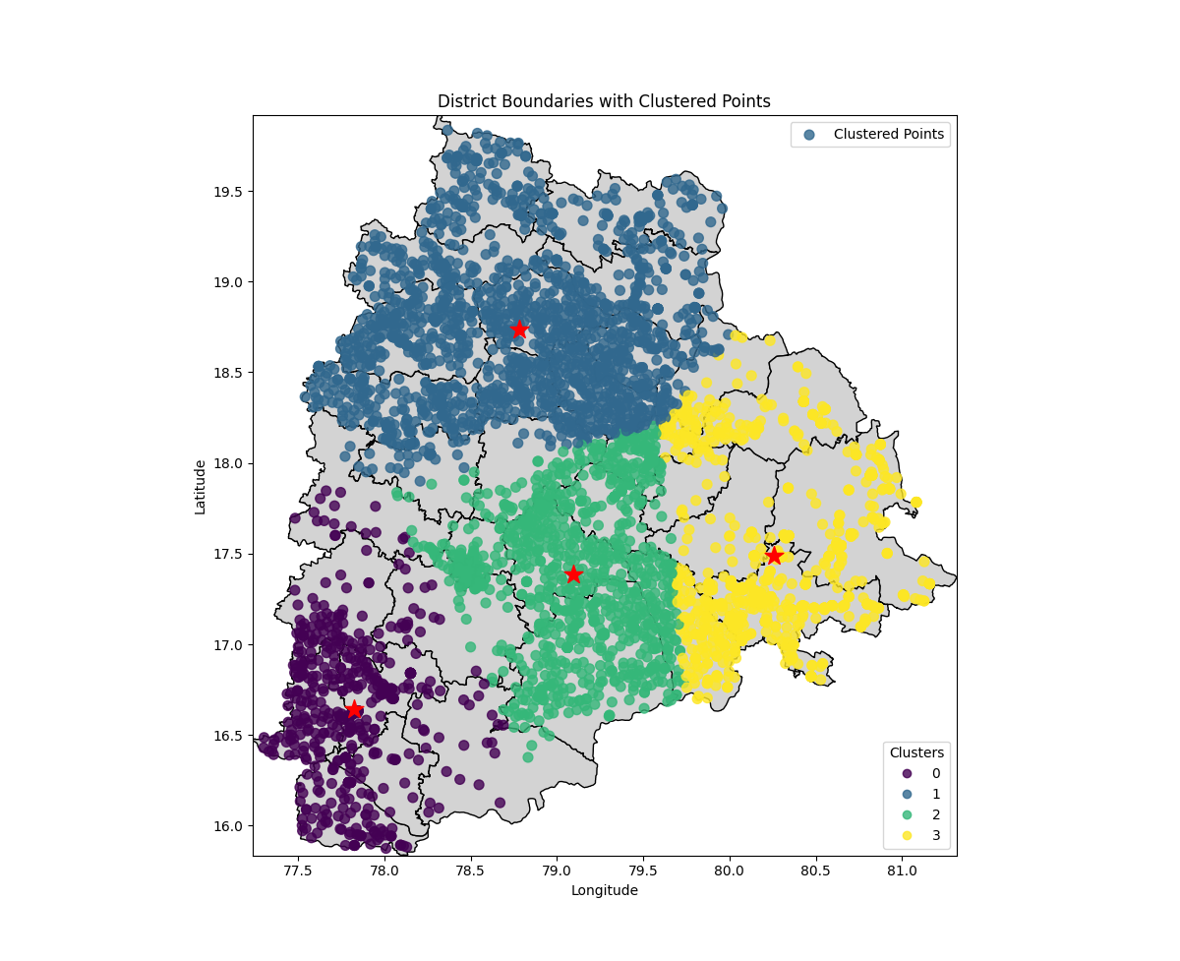

After comparing the map with a telangana map with districts :

I chose k = 20 from the elbow plot,

When I plotted with 3 centroids (k=3):

I found it looked like a cake being correctly divided into 3 parts. 😅️

It was evenly divided, where each centroid had 1/3 rd of the points, giving an idea that the population of telangana is distributed evenly in those 3 regions.

When I plotted with 4 centroids (k=4):

After comparing the maps with k = 3 and k = 4, the northernmost centroid in the map(k=3) did not change much in comparison to that of the map with k = 4.

the rest 2/3 rds of the map(k = 3) was divided into 3 parts.

This tells us that the population density in the north of Telangana is high and there is high density of pincodes. In Urban area a pin may cover smaller region. This tells us that Northern Telangana is more urbanized compared to Southern Telangana.

While in rural areas pin can cover larger areas. This tells us that Middle and eastern parts of Telangana are rural.

When I plotted k = 5, The northern region which finally split into 2 regions.

From k = 6, it became harder to analyze this data.

So, I used the elbow method and came to the conclusion that k = 20, fit best as all other values after that did not show any good change.

These are my inferences.

K = 5

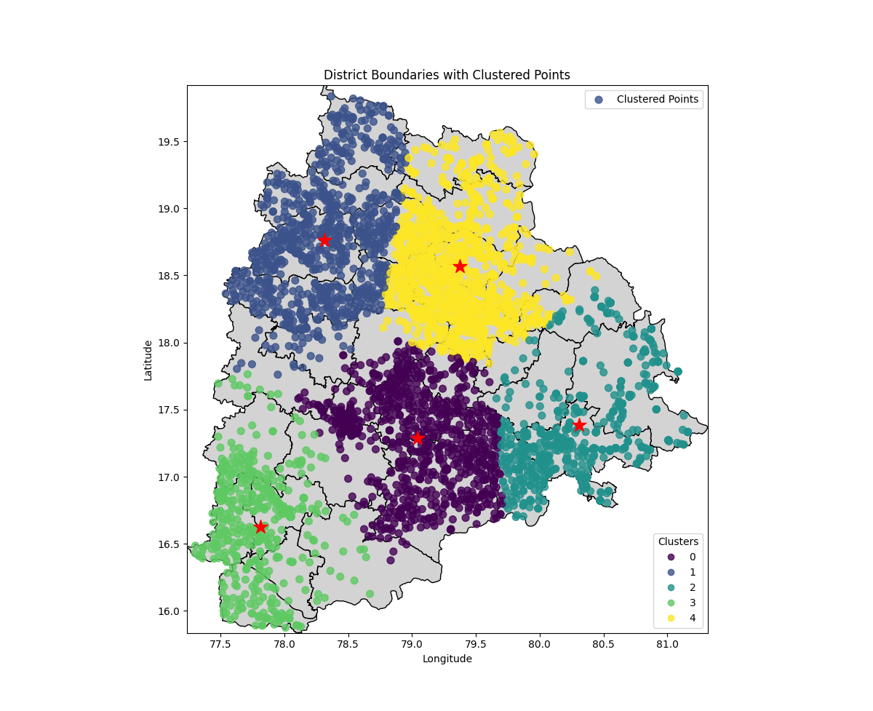

K = 6

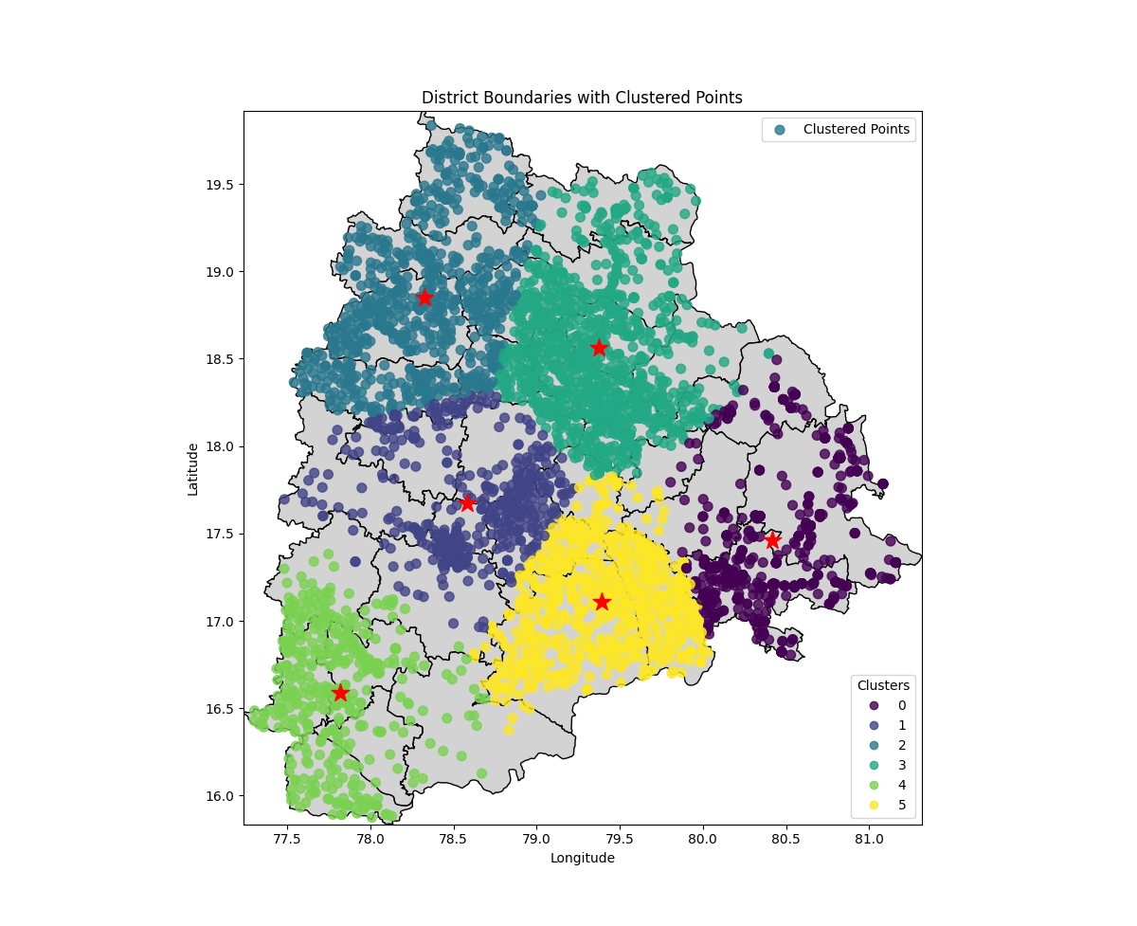

**CV + NLP**

Data interpreted from the images stored in a csv file:

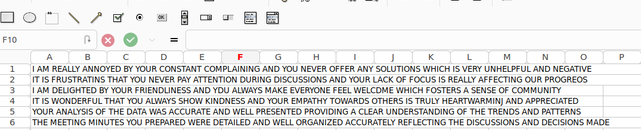

Sentiment Analysis:

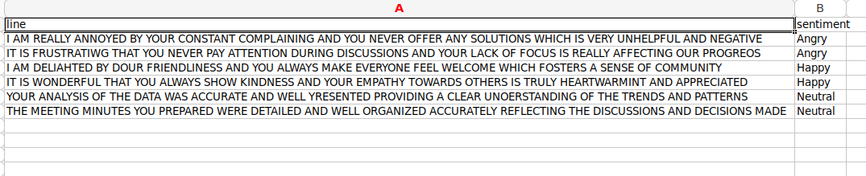

**Methods :**

I used the Elbow method (k_best_elbow.py) to come up with the best k value. The plot is in the k values folder.

For image processing, I cut the given image into 28*28 pixels to obtain the result.

I used Naive Bayes theorem to do sentiment analysis.

**Reference links:**

https://www.youtube.com/watch?v=5w5iUbTlpMQ

https://www.analyticsvidhya.com/blog/2022/03/building-naive-bayes-classifier-from-scratch-to-perform-sentiment-analysis/

https://www.youtube.com/watch?v=MV6dgAGTv-k&t=4s